

**How to Host a Mapathon**

A Step by Step Guide



**Table of Contents**

**Missing Maps Summary ………………………………………………..3**

**The Mapping Process…………………………………………………...4**

**Tips for a Successful Mapathon……………………………………....5**

**Mapping Resources……………………………………………………..9**

**Missing Maps Summary**

Recent disaster trends indicate that people are increasingly impacted by more frequent and severe disasters, particularly in vulnerable communities around the world. Urbanization has made matters worse; more than half the world’s population currently lives in cities, often located on coastlines and fault lines. These cities often lack sufficient infrastructure to support the informal settlements that have sprung up within them. One billion people – 1/7th of the world’s population – now live in urban slums (United Nations Development Report). Overcrowding, poorly-built dwellings, and insufficient infrastructure has left hundreds of millions of people increasingly vulnerable to disaster and disease.

A first step to assisting these communities is to ensure that we know where they are. The Missing Maps Project is an unprecedented collaboration between the American Red Cross, British Red Cross, Médecins Sans Frontières-UK (MSF-UK or Doctors Without Borders-UK) and the Humanitarian OpenStreetMap Team to map the world’s most vulnerable communities.

The Missing Maps Project has begun mapping locations where partner organizations are already conducting disaster preparedness and risk reduction activities. As major disasters strike, affected communities may also be prioritized.

Digital volunteer engagement is vital for the success of many humanitarian organizations around the world responding to disasters. It is imperative to have a larger pool of trained volunteers that are ready to assist with little coordination when a disaster occurs.

**The Mapping Process**

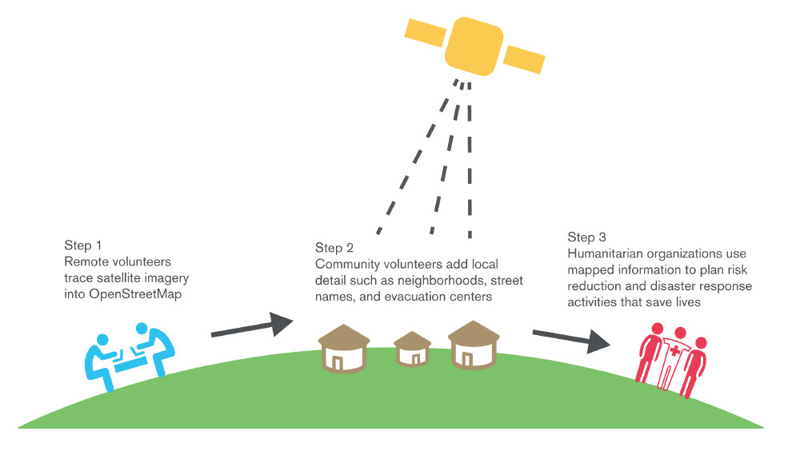

**Tips for a Successful Mapathon**

Mapathons are an engaging and cutting-edge opportunity designed to help deepen a volunteers’ relationship with the Missing Maps project. The objective of a mapathon is to engage volunteers to digitally map the most vulnerable places in the developing world so that local and international NGOs can use these comprehensive maps and data to better respond to crises affecting these areas.

**What You’ll Need:**

* Volunteers!
* A space that accommodates your group
* Tables & chairs
* Strong Wi-Fi that can handle multiple simultaneous connections
* A projector and screen
* Extension cables & Chargers
* Computers for each participant & a mouse, if possible
* Enthusiasm, drive, and a ready to make an impact mentality!

**Additional Useful Items:**

* Extra laptops, chargers, and mice
* Registration table
* Name tags
* Printed training materials
* Additional AV equipment (microphones, speakers)
* Snacks (we love pizza!)

**Planning the Mapathon**

Hosting a mapathon is relatively simple, and requires no special skills or previous mapping experience! Planning for a mapathon typically requires several weeks of advance notice in order to coordinate and prepare for the event.

**How the Missing Maps Team Can Help**

The Missing Maps team can support you in a number of ways. Please reach out to [jessica.bergmann@hotosm.org](mailto:jessica.bergmann@hotosm.org).

**Planning Checklist**

* Set a date and time for the mapathon. We suggest blocking off 2 hours, which will include:
  + 5-minutes to welcome people to the room and ask them to sign into their account
  + 5-minute welcome presentation
  + 10-minute presentation on Missing Maps
  + 10-minutes of mapping training
  + 15-minutes to get comfortable with a new skill
  + 70-minutes to map comfortably
  + 5-minutes to wrap-up
* Reserve a space that can comfortably hold your participants and their equipment. If you would like to have a registration table, don’t forget to account for that.
* Recruit helpers. They can help with presentations, trainings, registration, food/drinks, photography, and social media coverage.
* Ensure that the venue has a strong Wi-Fi connection that can support simultaneous connections from all of the computers. You may wish to test this before the event. Ensure that you have contact information for tech support at your location. Ensure that the Tasking Manager (tasks.hotosm.org), including imagery, passes your local firewalls.
* Create and distribute an invite through your internal organization/group. The Missing Maps project uses Eventbrite as an invite and RSVP tool for our mapathons.

**Planning Checklist continued:**

* Post about your event on social media. Don’t forget to tag us, we love hearing about events! Here’s how we can be reached: Twitter: @themissingmaps @hotosm – Use #missingmaps and Facebook: hotosm & MissingMapsProject
* If desired, arrange refreshments for the mappers.
* Choose a task for your group to map using the tasking manager. If you would like a suggestion on a task for your event, check the tasks available on your partnership page (Tasks are specific parts of the world that need to be mapped. We can provide suggestions for areas that need to be mapped or validated. This will be based on immediate priorities, level of mapping difficulty, and particular interests from your group.)
* Download and review mapathon materials. Please feel free to make these your own, keeping in mind the logo usage guidelines in the pack.
* Print mapathon materials, including name tags if desired.
* If desired, create a sign-up sheet for your participants. This is a good way to collect OSM usernames which you can use to track your groups work.
* Secure equipment, keeping in mind our mapping software is not compatible with Internet Explorer (IE) and we are not compatible with tablets. We are compatible with both Mac and PC.
* Make a playlist of music from the country you will be mapping to play at your mapathon. This one is optional but very enjoyable!!
* One week out, remind participates of your event and ask them to create an account on OSM. Now is also a great time to supply participants with hashtags and relevant social media accounts.
* Practice mapping and get excited!

**Event Day Checklist**

* Set up the room by putting out equipment, paper resources, and snacks. Set up the registration table as well if you have one. Don’t forget to tape your extension cables to the floor for safety!
* Test equipment to ensure everything is working correctly. If possible, test on both a Mac and PC.
* Check on your task to ensure there is enough work for your group. Pick a new task if needed and update your print materials.
* Set up snacks if you have them.

**Event Day Checklist continued**

* Cue up presentations and and focus your projector.
* Post pictures and information to social media.
* Have fun mapping!

**Post-Mapathon Wrap Up**

* If you used a unique hashtag, check the leaderboard for your groups contribution totals.
* Follow up and thank your participants using the follow up email template. Don’t forget to let them know about your group’s contribution totals and next event.
* Start planning your next event!

**Mapping Resources**

**Why Map?**

**Missing Maps Website:** <http://www.missingmaps.org>

**Humanitarian Remote Mapping Introductory Video:** <http://www.youtube.com/watch?v=C175zW8-6j8>

**Learn to Map:**

**MapGive Resources for new Mappers:** <http://mapgive.state.gov/learn-to-map/>

**OpenStreetMap Resources for new Mappers:** <http://learnosm.org>

**Wiki: How to label or “tag” mapped features:** <http://wiki.openstreetmap.org/wiki/Map_Features>

**Get started Mapping:**

**Tasking Manager:** <http://tasks.hotosm.org>

**OpenStreetMap (OSM):** <http://osm.org>

**Live OpenStreetMap Mapping - for display purposes:** <http://osmlab.github.io/show-me-the-way/>

**Donate and Volunteer:**

**Contribute to Missing Maps:** <http://www.missingmaps.org/contribute>